Concept of Operations
For
Imaging subsystem
Engr 430/330 Spacecraft Systems Engineering
Team Payload: Jun Zhou, Zexi Liu, Duwayne Lawson
Instructor: Dr Won
Mar, 18th 2007
- Background and Objectives
The PaperSat will take 1m resolution pictures in both visible and NIR bands of Temple University main campus. The operation altitude is 300 meters.
- Description of the Imaging Subsystem
  - Major System Components
There will be a CMOS or CCD sensor module which works in visible band. And also the subsystem includes an imaging sensor which works in NIR bands.
  - Interfaces to External Systems and Data Flow
Essentially it’s the interface between imaging sensors and Micro-Controller Unit and Power Unit.
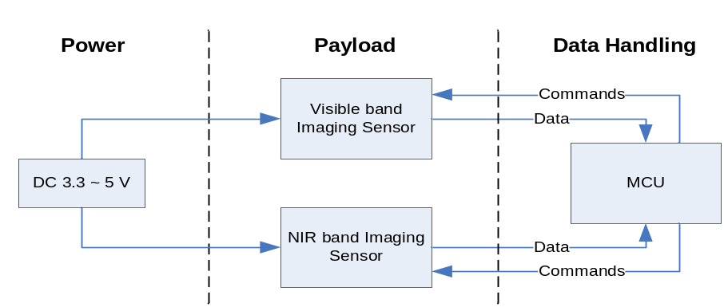
  - Capabilities or Function of the Proposed System
After receiving commands from the MCU, the imaging system will put imaging data on data bus. The response time will vary among different imaging sensors. Low power consumption is important for this system.
- Modes of Operation
Sleep mode: the sensors are off as long as there is no “wake-up” command.
Running mode: waiting the commands from MCU.

